Modelling Glacier Dynamics and Sea Level Rise for Future Projections in the Gulf of Alaska

Harsh Mahanti  Amity Institute of Information Technology  Amity University Jharkhand  Ranchi, India  mahantiharsh@gmail.com | Swayam Gupta  Amity Institute of Information Technology  Amity University Jharkhand  Ranchi, India  swayamgupta5698@gmail.com | Roumo Kundu  SAP TLL VT India BLR  SAP Labs BLR  Bangalore, India  rjroumo@gmail.com
Tannisha Kundu  Amity Institute of Information Technology  Amity University Jharkhand  Ranchi, India  tkundu@rnc.amity.edu | Taha Fatma  Amity Institute of Information Technology  Amity University Jharkhand  Ranchi, India  tahafatma3535@gmail.com | Piyush Jaiswal  Amity Institute of Information Technology  Amity University Jharkhand  Ranchi, India  piyushjaiswal2203@gmail.com

Abstract— In the last few years, there has been a significant change in the sea level of Alaska by the melting of glaciers, due to which the flora and fauna in the coastal region have been endangered. Accurate prediction and analysis of change in sea level is crucial for the policymakers and protective agencies to take proper measures against the change. Existing studies don’t properly predict the changes in the glacier mass, glacier health or the changes in the sea level. The main problem lies in the unavailability of data. This research provides a deep analysis of glacier mass change from 1985-2021 extracted from a remote sensing timelapse video, and it predicts the changes in glacier health and sea level from 2021-2026. This solution uses various image processing techniques to extract data from the video's image sequence and uses the LSTM and RNN models ensembled together to predict future changes with an accuracy of 80%. This prediction provides a solution for various policy-building organisations to be ready for a change in habitat.

Keywords—Alaska, glacier health, coastal region, glacier mass, LSTM, RNN

Introduction
Glaciers play a crucial role in the Earth's climate system and significantly contribute to global sea level rise. Recent studies have highlighted the alarming rate of glacier mass loss worldwide, with substantial implications for sea level rise, freshwater resources, and regional hydrology. The Intergovernmental Panel on Climate Change (IPCC) has projected a likely global mean sea level rise of between 0.43 m and 0.84 m by 2100 under a high emission scenario (RCP 8.5) (IPCC, 2021) [2]. This rise poses significant threats to coastal communities, infrastructure, and ecosystems worldwide. From 2019 to 2023, global glaciers experienced a significant mass loss of approximately −331.68 ± 59.07 Gt/yr, contributing to a sea level rise of 0.916 ± 0.163 mm/yr [1]. Notably, Alaska emerged as the foremost contributor to global glacier mass change, with a substantial mass balance loss of approximately −57.11 ± 7.68 Gt/yr [1]. This deceleration in mass loss contrasts with the accelerated mass loss observed in other regions, such as the southern Canadian Arctic and the southern Greenland Periphery. The Gulf of Alaska (GOA) stands as an ideal research site because it contains diverse terrain features together with both heavy rainfall and significant ice coverage. To understand and quantify changes in glacier mass, four main methods are commonly used: glaciological, digital elevation model (DEM) differencing, altimetry, and gravimetry. Repeat observations from optical and radar DEMs provide detailed glacier elevation data at high temporal and spatial resolution. The IPCC’s sixth assessment report (AR6) complemented glaciological observations with global glacier mass balance from DEM differencing, using results from gravimetry for evaluation [2]. Furthermore, a broad range of mass balance estimates exists within the literature, emphasizing the challenges inherent in accurately measuring and modeling glacier dynamics, the major runoff sequences for GOA is shown in Figure 1. [6]
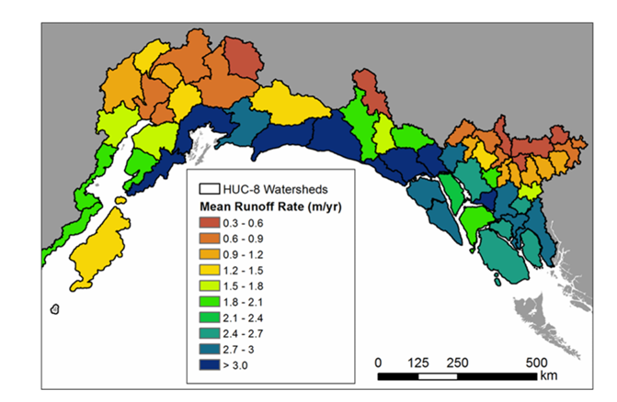
Figure 1 Map of mean annual runoff rate (in m / yr21)
The Kenai Peninsula in south-central Alaska has experienced significant glacier mass loss, with a 12% area shrinkage between 1986 and 2016. The region-wide mass-balance rate between 2005 and 2014 was −0.94 ± 0.12 m w.e. a−1, indicating an acceleration in glacier mass loss. [3] This region's glaciers contribute significantly to global sea level rise and freshwater input into the Gulf of Alaska.

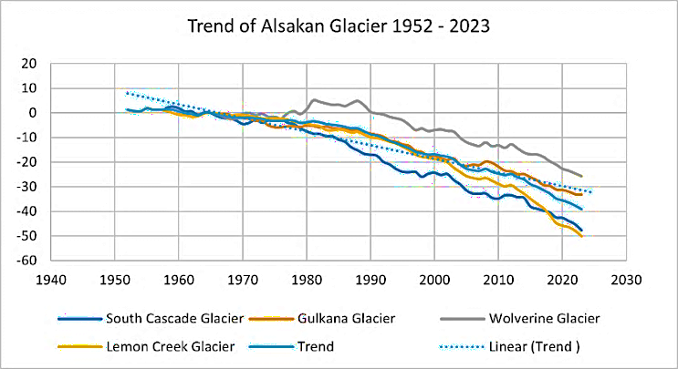
Figure 2 Mass balance trends of Alaskan glaciers (1952-2023)
The current state of GOA glaciers reflects a complex interaction of various factors. Globally, glacier mass loss is accelerating [1], with Alaska playing a substantial role for whose a historical trend pattern is plotted for the 4 Major Glaciers of Alaska in Figure 2. [10]

This research aims to develop a robust pipeline for processing images, extracting meaningful features, generating datasets, analyzing data, and deploying models to study glacier mass balance changes. The research begins with extracting frames from glacier timelapse and segmenting them into 300 individual frames, which then undergo image processing to enhance quality and identify key features through segmentation. 9 Statistical features are derived from these processed frames, complementing data acquired from existing research, including geographical facts about the glaciers. The dataset represents the glacier's characteristics over 36 years, with each row corresponding to a specific year from 1986 to 2021. This combined dataset is then pre-processed, analyzed, and normalised to prepare it for modelling.

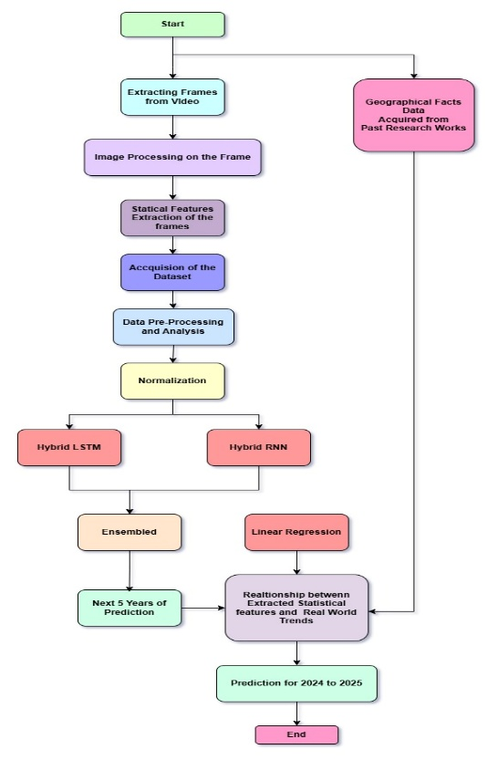
Following image processing, the extracted features are used to generate datasets for training and testing machine learning models. Data analytics is performed to gain insights into the datasets and prepare them for model training. Different machine learning models, including ensemble models, Long Short-Term Memory (LSTM) networks, and Recurrent Neural Networks (RNNs), are tested to evaluate their performance and suitability for the given task. The best-performing models are then prepared for deployment.

The results from these two models were then ensembled to obtain optimized forecasts for the years 2022 to 2026. Additionally, linear regression is utilized to establish a relationship between the extracted statistical features and real-world glacier trends. estimate the glacier's mass balance and sea level contribution, which are crucial indicators of the glacier's health and the region's environmental changes.
This comprehensive workflow showcases the integration of image processing, machine learning, and data analytics to solve complex problems effectively. By providing a detailed methodology for developing and deploying machine learning models for image processing tasks, this research aims to contribute to the field and serve as a valuable reference for future studies and applications in related domains.

LITERATURE REVIEW
The Kenai Peninsula experienced a 12% area shrinkage between 1986 and 2016. The region-wide mass-balance rate between 2005 and 2014 was −0.94 ± 0.12 m w.e. a−1, indicating an acceleration in glacier mass loss. The glaciers have experienced widespread recession since the Little Ice Age. [3]
Climate models predict that the Gulf of Alaska (GOA) will become warmer and wetter, significantly reducing snowpack and glacier extent. For RCP 4.5, reductions in glacier volume and area resulted in a 30% decrease in annual glacier runoff between 2003–2022 and 2080–2099. [6]
Ice flow plays a fundamental role in glacier dynamics and hazards. In Alaska, glacier speeds are 50% greater in spring than the annual mean. Lake-terminating and tidewater glaciers flow faster than land-terminating glaciers. Glacier Lake Outburst Floods (GLOFs) can cause significant speed-ups in glacier flow. [7]
Recent studies highlight the alarming rate of glacier mass loss, significantly contributing to global sea level rise. From 2019 to 2023, global glaciers lost approximately −331.68 ± 59.07 Gt/yr, equating to a sea level rise of 0.916 ± 0.163 mm/yr. Alaska was the foremost contributor, with a mass balance loss of −57.11 ± 7.68 Gt/yr. [1]

Alaska has been a significant focus due to its substantial contribution to global sea level rise. The region-wide mass-balance rate between 2005 and 2014 was −0.94 ± 0.12 m w.e. a−1, indicating an acceleration in glacier mass loss. Alaskan glaciers account for approximately 12% of the total global glacierized area, excluding the Greenland and Antarctica ice sheets. [3]

METHODOLOGY
The workflow structure and implementations of the study have been mentioned below in the sections discussed in the sections ahead. The procedure starts with the extraction of frames from glacial timelapse, followed by the segmentation into 300 distinct frames, which subsequently undergo image processing to improve quality and discover essential elements using segmentation. Statistical characteristics are extracted from these processed frames, augmenting data obtained from prior studies, including geographical information on the glaciers.
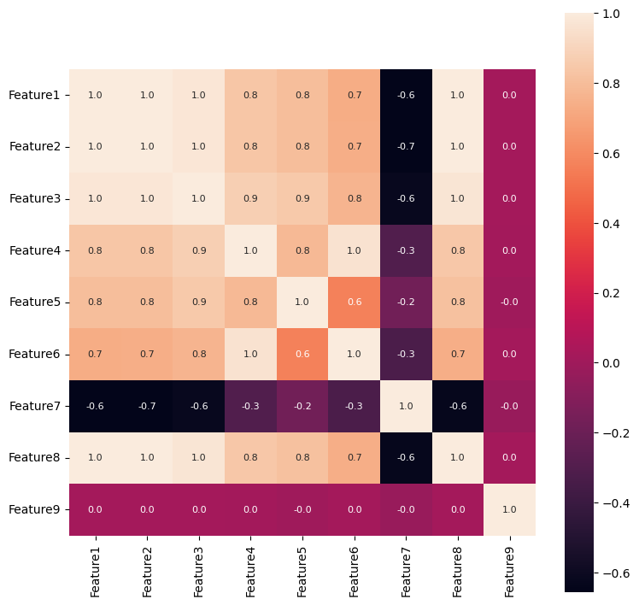
The integrated dataset is subsequently pre-processed, analyzed, and normalized to facilitate modeling. Two hybrid models, a Long Short-Term Memory (LSTM) network and a Recurrent Neural Network (RNN), are trained, and their outputs are ensembled for improved prediction. The results from these two models are then ensembled to obtain optimised forecasts for the years 2022 to 2026. Additionally, linear regression is utilized to establish a relationship between the extracted statistical features and real-world glacier trends, estimating the glacier's mass balance and sea level contribution. The proposed architecture is described in Figure 3.

DATA ANALYSIS
The numerical and statistical features of the dataset, used for projections, were extracted over from the Timelapse footage of 300 frames, constituting 300 rows and 9 features, respectively. The details of the extracted features are described as follows,

- Feature_1 - Processes an image to compute the percentage of pixels that have a high intensity, based on a dynamic threshold and the frequency of pixel intensities
- Feature_2 - The Frobenius norm is calculated for the grayscale version of an image, providing a numerical value that represents the overall intensity magnitude of the image.
- Feature_3 - Detects the largest region, computes its convex hull, crops the image, and applies Frobenius Norm on it.
- Feature_4 – Calculates the diagonal length of the cropped image by applying the Pythagorean theorem.
- Feature_5 – Calculates the Width of the cropped image by applying the Pythagorean theorem.
- Feature_6 – Calculates the Height of the cropped image by applying the Pythagorean theorem.
- Feature_7 - Compute the percentage of pixels that have the lowest intensity based on a dynamic threshold and the frequency of pixel intensities.
- Feature_8 - Calculate the ratio of white family pixels to black family pixels.
- Feature_9 – Calculates Pixel rate Change with Subsequence Subtraction of Images.

These 9 features’ characteristics are computed and the data reveals that Feature 1 and Feature 8 exhibit small ranges together with minimal standard deviations indicating small variations. The large values combined with higher standard deviations of Feature 2 and Feature 3 indicate notable variations across the study parameters. Data from Feature 4, Feature 5, and Feature 6 demonstrate average size values while containing significant variations of moderate scope. Feature7 demonstrates stability across a narrow range yet Feature 9 reveals substantial differences between its lowest point (0) and highest point (11.55) along with high standard deviation levels due to occasional extreme fluctuations.

IQR detects outliers by identifying values exceeding 1.5 times the IQR beyond Q1 and Q3. Analysis revealed significant outliers in Feature3 (12), Feature5 (52), and Feature9 (44), potentially indicating unusual data points or distribution variations. All other features maintain standard distribution patterns, suggesting relative stability. Features 5 and 9 show notably high outlier counts, warranting further investigation into their distribution anomalies and extreme values.
The correlation matrix in Figure 4, reveals strong positive relationships among many features, especially between Features 1, 2, and 8, indicating they likely capture similar patterns. Features 3 and 4 also show a strong positive correlation. Feature 7, however, exhibits moderate negative correlations with several other features, suggesting an inverse relationship or a unique role in the dataset. Feature 9 remains largely uncorrelated with different features, indicating it varies independently. Overall, the dataset appears to have highly interrelated features, with some, like Feature 7, displaying contrasting behavior. These insights suggest potential redundancy among features. To assess variability and determine significant differences between multiple groups in the dataset, One Way ANOVA was implemented. The null hypothesis states equal means across groups, while the alternative hypothesis suggests at least one group mean differs from others.
$$F=\frac{\text{Between-group variance}}{\text{Within-group variance}}=\frac{\frac{1}{k-1}\sum_{i=1}^{k}{n_{i}{\left(\overline{X_{i}}-\overline{X}\right)}^{2}}}{\frac{1}{N-k}\sum_{i=1}^{k}{\sum_{j=1}^{n_{i}}{{\left(X_{ij}-\overline{X_{i}}\right)}^{2}}}}$$

ANOVA testing yielded an F-value of 63114.40 with a p-value of 0.0000, providing strong evidence against the null hypothesis. All feature pairs showed statistically meaningful differences with p-values of 0.000000e+00, confirming significant differences between feature means and justifying rejection of the null hypothesis.
$$ΔF\left(t\right)=F\left(t\right)-F\left(t-1\right)$$
To validate claims of glacial melt deceleration between 2019-2023 compared to the previous decade, year-over-year changes were analyzed using equations:
$$\text{Average Annual Rate of Change (2009-2018)}=\frac{1}{N_{\text{before}}}\sum_{t=2009}^{2018}{ΔF\left(t\right)}$$
$$\text{Average Annual Rate of Change (2019-2023)}=\frac{1}{N_{\text{after}}}\sum_{t=2019}^{2023}{ΔF\left(t\right)}$$
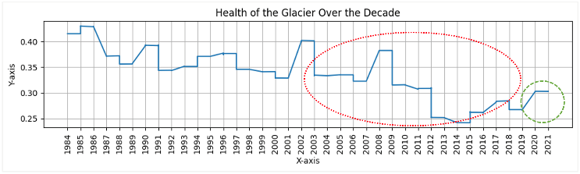
Figure 5 Glacier Health over The Decade
Features 1 and 8, which closely correlate with glacier health, showed growth from -0.0002 to 0.0008 and from -0.0003 to 0.0010 respectively. A composite "Health of the Glacier" metric was formulated as shown in Figure 5. Rate of change was calculated using linear regression:
$$y = m ⋅x + c$$
$$m=\frac{\sum_{i=1}^{n}{\left(x_{i}-\overline{x}\right)\left(y_{i}-\overline{y}\right)}}{\sum_{i=1}^{n}{{\left(x_{i}-\overline{x}\right)}^{2}}}$$
Analysis revealed contrasting trends: a negative rate of change (-0.0016) from 2002-2019 indicating glacier degradation, followed by a positive rate (0.0089) from 2019-2021 suggesting stabilization or improvement. T-tests comparing these periods used the formula:
$$t=\frac{S_{1}-S_{2}}{\sqrt{\frac{s_{1}^{2}}{n_{1}}+\frac{s_{2}^{2}}{n_{2}}}}$$
Results showed significant changes with t-statistics of 3.8126 (p=0.0003) for Feature1 and 3.9771 (p=0.0002) for Feature 8, confirming real changes in glacial dynamics rather than random variation. Statistical analysis of glacier mass loss and sea level rise using Pearson correlation revealed an extremely strong positive correlation of 0.9964. Regression analysis yielded R-squared values near 1.000, with highly significant F statistics (4.668e+29) and a p-value of 0.025, confirming the robust relationship despite potential multicollinearity indicated by high condition numbers. These findings conclusively demonstrate that glacier mass loss directly impacts sea level rise, while suggesting further investigation into additional climatic and glaciological factors.

MODELLING
The experimentation as described in Figure 6 starts with Grayscale Conversion of the Frame , the input image I in the RGB color space is converted to a grayscale image I_{g}​ using the weighted sum of its color channels ,
$$I_{g}\left(x,y\right)=0.299R\left(x,y\right)+0.587G\left(x,y\right)+0.114B\left(x,y\right)$$ | (8)
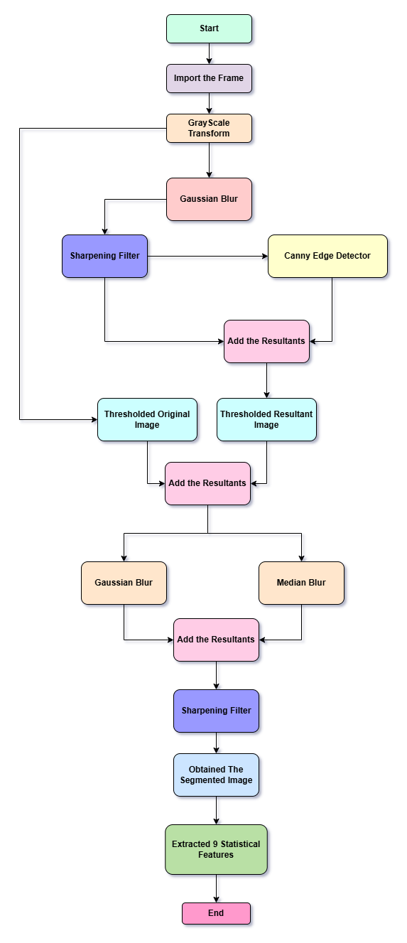
A Gaussian blur is applied to smooth the image, reducing noise and fine details. The filtered image I_{d}​ is computed using a Gaussian kernel,
$$I_{d}\left(x,y\right)=\sum_{i=-k}^{k}{\sum_{j=-k}^{k}{I_{g}\left(x+i,y+j\right)}}⋅G\left(i,j\right)$$ | (9)
where G(i,j) is the Gaussian kernel with kernel size of 15 ,
$$G\left(i,j\right)=\frac{1}{2πσ^{2}}e^{-\frac{i^{2}+j^{2}}{2σ^{2}}}$$ | (10)
In mathematical terms, image sharpening using 2D convolution applies a sharpening kernel K_{s}​ to an image I_{d}​, producing a sharpened image Is​. The convolution operation can be defined as,
$$I_{s}\left(x,y\right)=\sum_{i=-1}^{1}{\sum_{j=-1}^{1}{K_{s}\left(i,j\right)}}⋅I_{d}\left(x+i,y+j\right)$$ | (11)
where K_{s}​ is the sharpening kernel,
$$K_{s}=\left[\begin{matrix}-1 & -1 & -1 \\ -1 & 9 & -1 \\ -1 & -1 & -1\end{matrix}\right]$$ | (12)
Edges are detected using the Canny edge detector, which computes gradients using Sobel filters to compute intensity gradients in the x and y directions with lower and upper threshold of 100 and 200,
$$G_{x}=I_{s}*\left[\begin{matrix}-1 & 0 & 1 \\ -2 & 0 & 2 \\ -1 & 0 & 1\end{matrix}\right],$$ | (13)
$$G_{y}=I_{s}*\left[\begin{matrix}-1 & -2 & -1 \\ 0 & 0 & 0 \\ 1 & 2 & 1\end{matrix}\right],$$ | (14)
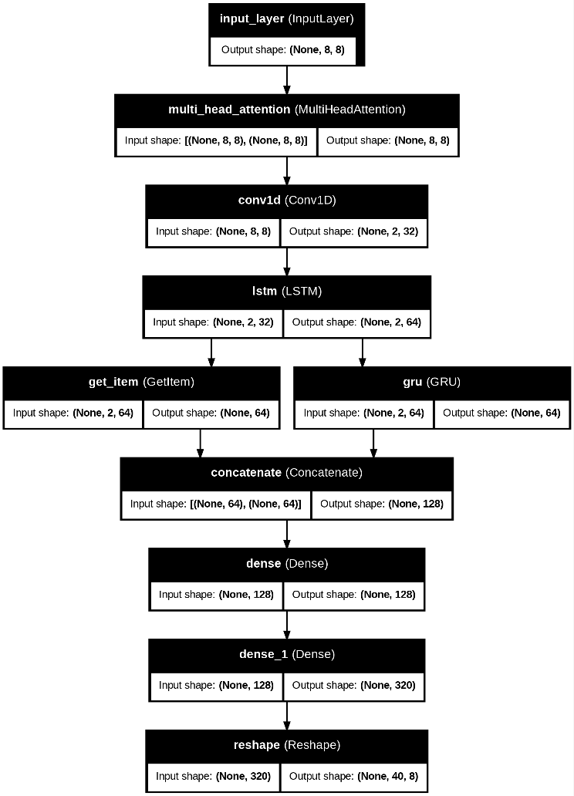
The gradient magnitude is,
$$G=\sqrt{G_{x}^{2}+G_{y}^{2}}$$ | (15)
The gradient magnitude is calculated as,
$$θ=\tan^{-1}\left(\frac{G_{y}}{G_{x}}\right)$$ | (16)
The resultant is applied with Laplacian Filter, which is computed by applying a kernel to the image. The kernel for the discrete Laplacian in 2D is,
$$L=∇^{2}I_{s}=\frac{∂^{2}I_{s}}{∂x^{2}}+\frac{∂^{2}I_{s}}{∂y^{2}}$$ | (17)
where the Laplacian kernel is,
$$K_{L}=\left[\begin{matrix}0 & 1 & 0 \\ 1 & -4 & 1 \\ 0 & 1 & 0\end{matrix}\right]$$ | (18)

The resultants of the Laplacian and Canny Edges are combined using element-wise addition, with a binary thresholding operation applied on to it, where T is 140,
$$I_{th}\left(x,y\right)=\left\{255,\text{ if }I_{added}\left(x,y\right)>T\text{ else }0\right\}$$ | (19)

This added resultant is applied with Median Blurring to remove salt and pepper noise, to replace each pixel with the median value of the pixels in its neighborhood,
$$I_{M}\left(x,y\right)=\text{median}\left(I_{th}\left(x+i,y+j\right)\right), i,j∈W$$ | (20)
where W is a neighborhood window.

On the Original Grayscale Image (8) and the Added image for the filters, Thresholding is applied as in (19) with a value of 140 to 255, and Added these two resultants. The resultant is then applied with Gaussian Blur in (9) . This gaussian Blurred image is Added up with Median Blurred Image resultant, this is specifically done to highlight the specific Glacial region and probable Runoff areas. This resulted the Segmented Glacial areas of the frames.

The Segmentation procedure was validated over a manually selected 50 frames out of the 300 frames. Mathematically, image segmentation performance can be described with a confusion matrix, a 2x2 matrix listing TP, FN, FP and TN values. The confusion matrix will help us determine the segmentation accuracy and precision.
$$\text{Accuracy}=\frac{\text{TP}+\text{TN}}{\text{Total Predictions}}$$ | (21)
$$\text{Precision}=\frac{\text{TP}}{\text{TP}+\text{FN}}$$ | (22)
Used the feature extraction algorithm to extract 9 features can be ref in repo. The first implementation show in Figure 7 employs a custom RNN with several specialized components:
- A multi-head attention mechanism with 4 heads and 8 dimensions per head to capture temporal dependencies
- A temporal convolutional layer with 32 filters, kernel size of 4, and dilation rate of 2
- Sequential LSTM (64 units) and GRU (64 units) layers to process the sequential time-series data
- Concatenation of outputs from both recurrent layers
- Dense layers (128 units) for final prediction formatting

This architecture is optimized using the Adamax optimizer with a learning rate of 0.02 and trained for 150 epochs with a batch size of 20. The model processes input sequences of shape (8, 8) and produces output sequences of shape (40, 8), representing 8 timesteps of historical data to predict 40 future
timesteps. The LSTM implementation shown in Figure 8 features:
- Initial LSTM layer (64 units) with dropout regularization (0.2)
- GRU layer (64 units) with dropout (0.2)
- Attention mechanism applied to the concatenated outputs
- Flattening operation followed by dense layers
- Reshape operation to produce the desired output format

This model uses the same Adamax optimizer but with a lower learning rate of 0.002 and includes early stopping with
patience of 100 epochs to prevent overfitting. The ensemble methodology employs a weighted averaging technique based on inverse RMSE values based on the RMSE scores obtained from LSTM and RNN.

Statistical analysis of the ensemble predictions through one-way ANOVA showed significant differences between features (F-statistic: 9.80, p-value < 0.0001). This confirms the heterogeneity of the various glacier characteristics being monitored. The rate of change analysis between 2022 and 2026 for Feature1 (-0.1160) and Feature8 (-0.1202) indicates a gradual but consistent decline in these glacier health

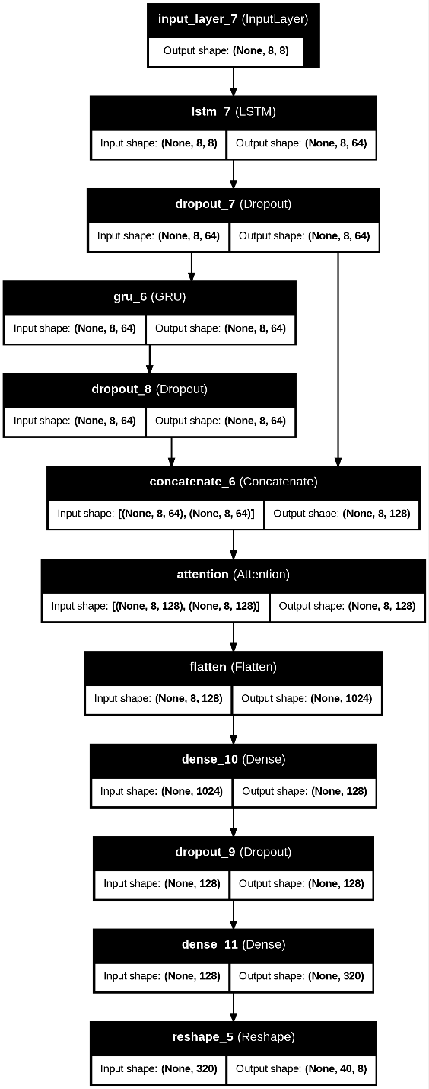
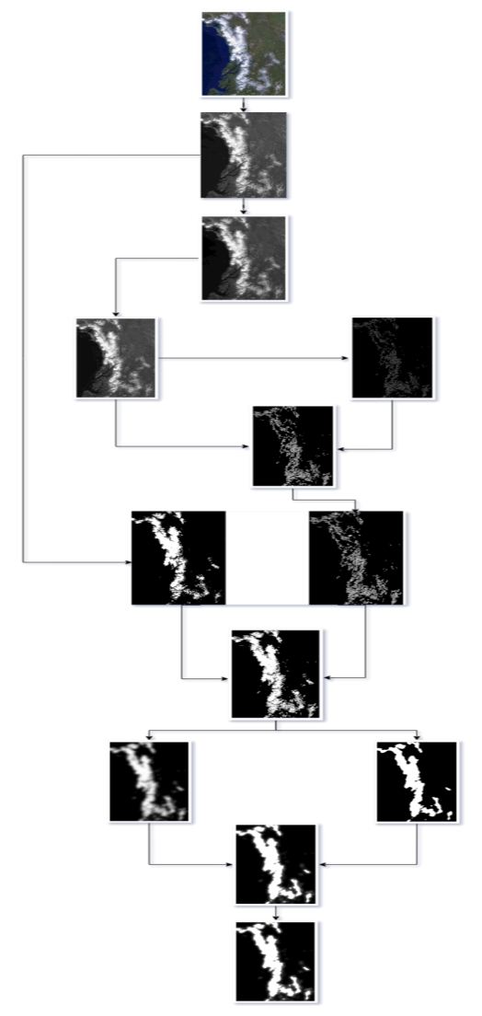
indicators over the forecast period, suggesting continued environmental impact that warrants monitoring. The overall glacier health metric, calculated as the average of Feature1 and Feature8, was projected with a negative slope of -0.0093, confirming a statistically significant downward trend in the glacier's condition over the forecast period. This ensemble modelling approach provides a robust framework for long-term monitoring and prediction of glacier changes, with potential applications in climate science and environmental management. Feature 1 represents the Percentage of high-intensity pixels , Feature 2 is the Frobenius normalization of the image , Feature 3 is the Frobenius norm of the cropped image , Feature 4 is Diagonal length of the cropped image ,Feature 5 is Width of the cropped image , Feature 6 is Height of the cropped image Feature 7 gives Percentage of low-intensity pixels and Feature 8 is Ratio of white to black pixels . Then the last feature contains the information about the date we have taken 8 frames per year for this data. The study gather additional relevant information, including historical data on the glacier's past behavior (size, mass balance, flow rate), climate data encompassing temperature and precipitation patterns that influence glacier dynamics, and topographic data, potentially in the form of Digital Elevation Models (DEMs), providing crucial context about the glacier's environment. Critically, this step also involves the acquisition of "Geographical Facts" derived from past study, suggesting the integration of existing knowledge about the specific glacier or region into the model.

RESULTS AND DISCUSSION
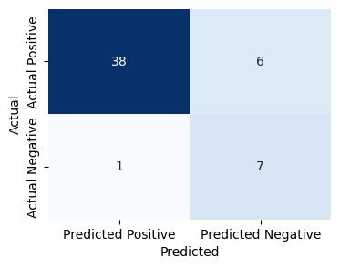
In the proposed image processing algorithm shown in Figure 9, the workflow for extraction and analysis of glacier regions from satellite imagery is structured. First, we perform grayscale conversion of the input satellite image to enhance it over contrast. To outline the glacier boundaries, edge detection techniques such as Canny edge detection are used. The segmentation is refined by a series of adaptive thresholding and morphological operations to isolate the glacier area form the background. The image so produced is iteratively processed by noise removal and region-based filtering to sharpen the accuracy. Also illustrating the glacier extent, the final processed image is clearly advantageous for further quantitative analysis. Finally, the transformation of the raw satellite imagery to the well segmented binary representation shows that the algorithm is suitable to automate glacier delineation for climate studies. The segmentation algorithm was evaluated using 50 images and confusion matrix was used to determine the performance metrics. The model correctly segmented glaciers in 38 images (true positives) but had failed in detecting significant portions of glaciers in 6 cases (false negatives). Furthermore, 7 cases were correctly identified as non-glacier regions (true negatives) as well as 1 image had extraneous segmented regions (false positive). For the segmentation model, it was found to be 90.0% overall accuracy in correctly

classifying glacier regions. 86.36% precision of the model means that the proportion of correctly segmented regions amongst all predicted positives is very good, making a good trade-off between false detection and high segmentation fidelity. The confusion matrix visualization proves the segmentation performance with the distribution of correct and incorrect classifications here in Figure 10.
The key insights in the performance evaluation of the Structured Hybrid LNN and Hybrid LSTM models were found and can be found in Figure 11.
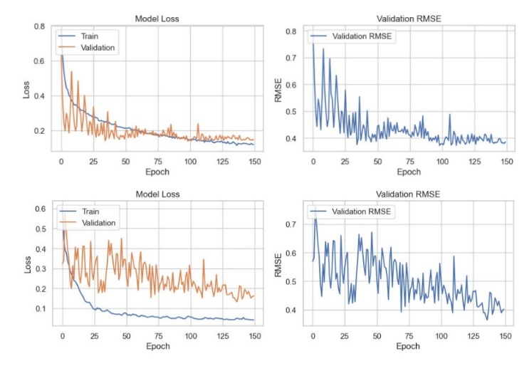
Figure 11 LSTM and RNN's Testing Performance
The training loss for the Hybrid LSTM was 0.119 and the validation loss was 0.148. Validation resulted in RMSE, MAE and MAPE of 0.385, 0.330 and 88.136, respectively and validation precision was 7.366.

However, the Hybrid RNN achieved a lower training loss of 0.041 though with a slightly higher validation loss of 0.161. Validation RMSE, MAE and MAPE were 0.402, 0.316 and 151.544 respectively with a validation precision of 7.142. Even further optimization of the results was achieved by the ensemble setup with both methodologies applied together, resulting in a final RMSE of 0.364, a final MAE of 0.312, a final MAPE of 127.693 and a final model precision of 0.805, some 10% better than that from the individual methodology approaches. These findings support the ensemble model’s ability to improve prediction accuracy at the expense of error metrics.

Table 1. Metrics Obtained for the Training Phase after Validation
Model | Training Loss | Validation RMSE | Validation MAE | Validation MAPE | Validation Precision
LSTM | 0.106 | 0.324 | 0.237 | 103.140 | 1.646
RNN | 0.047 | 0.216 | 0.126 | 56.329 | 1.681

The post-ensembling analysis revealed significant differences among key extracted features, as confirmed by a one-way ANOVA (F = 32844.81, p < 0.0001). Year-over-year analysis for 2022-2026 indicated a slight decline in glacier attributes, with Feature1 averaging -0.0004 and Feature8 averaging -0.0005 in annual change. Additionally, a linear regression on health metrics over time showed a negative trend, with a calculated slope of -0.0044, indicating a gradual decline. These insights underscore the continuous degradation in glacier conditions and associated environmental impacts shown in Figure 12.

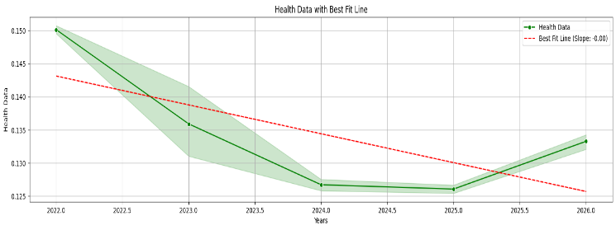
Figure 12 Trend of the Metrics of the GOA
Analysis shows near perfect correlation between glacial mass change and sea level rise at the Gulf of Alaska (GOA) with Pearson correlation coefficients of 0.9964 (mass1 vs. sea1), 0.9867 (mass2 vs. sea2) respectively and statistically significant (p-value = 0.0). The results of the regression establish that sea level rise is strongly affected by glacial mass loss with an R² value of 1.000, showing an almost perfect linear relationship, however, the high condition number (3.030) suggests the presence of multicollinearity. The model provides a unique direct link to glacier mass loss and regional sea level change, and these findings underscore the importance of precise monitoring necessary for understanding climate impact the projected resultant of the mass change and sea level rise in Table 2.

Year | Mass Change (Gt/yr) | Sea Level Change (mm/yr)
2024 | -10.85 ± 1.45 | -0.0208 ± 0.0028
2025 | -19.32 ± 2.59 | -0.0459 ± 0.0061
2026 | -28.71 ± 3.85 | -0.0738 ± 0.0098
Table 2 Impact and projection of glacial discharge and sea level alteration in GOA

Table 3. Comprehensive Trend for the Region of GOA

In 2024 to 2026,the based on glacier runoff scale, we find a striking and consistent increase in glacier loss for the Gulf of Alaska region as shown in Table 3, followed by a critical climate signal of diminishing glacier mass at an accelerating rate resulting in regional sea level rise. We project that specifically glacier runoff volume will decrease from –10.85 ± 1.45 km3/year in 2024 to –28.71 ± 3.85 km3/year in 2026, that is, 2.3 times more mass loss over a span of only three years. As with the contribution from glacier melt, the normalized annual sea level contribution also climbs from –0.021 ± 0.003 mm/year to –0.074 ± 0.010 mm/year which demonstrates the increasing contribution of those glaciers and at a rapidly growing rate. Regional climate projections on a high-emission scenario are consistent with these trends, and they coincide with glacier retreat on a large scale observed for the Gulf of Alaska. All these present patterns might contribute to very serious environmental change in this region by the end of this decade. Together, the data strengthen the case for increased glaciological monitoring, adaptive water resource management and strong policy responses to reduce or respond to rising environmental consequences from cryospheric change.

LIMTATIONS
- Temporal Resolution Constraints: Fixed-interval imagery misses rapid transitional events between sampling periods.
- Model Architecture Scope: Two-architecture ensemble inadequately captures complex non-linear glacial dynamics.
- Geospatial Generalizability: Alaska-specific models lack transferability to diverse global glacial systems.
- Dataset Size Limitations: Limited dataset inadequately represents glacial variability across conditions and timescales.

FUTURE SCOPE
- Integration of Multi-Modal Data Sources: Integrating multi-modal data for comprehensive modelling of glacier-environment interrelationships.
- Advanced Architectural Exploration: Exploring transformer architectures and physics-informed networks for improved predictive accuracy.
- Spatial-Temporal Resolution Enhancement: Enhancing spatial-temporal resolution to detect fine-scale glacial threshold behaviours.
- Geospatial Transferability Analysis: Extending methodology to diverse global glaciers for universal monitoring framework.

CONCLUSION
This research presents an innovative ensemble approach for glacial monitoring, integrating RNN and LSTM architectures through a weighted methodology based on inverse RMSE values. The implementation demonstrated robust predictive capabilities with final metrics of RMSE 0.3645, MAE 0.3118, and precision 0.805, confirming the effectiveness of combining complementary deep learning models for environmental monitoring. Statistical analysis revealed significant glacial deterioration trends from 2022-2026, with negative slopes for key features providing quantitative evidence of ongoing environmental change. The weighted ensemble architecture, assigning proportionate influence to RNN (0.4893) and LSTM (0.5107) models, successfully leveraged their respective strengths while mitigating individual weaknesses. This computational approach contributes valuable methodological advancements to climate science by enabling precise quantification and prediction of glacial changes. The framework's demonstrated capacity to forecast long-term glacial dynamics offers critical insights for environmental management and policy development, particularly for vulnerable polar ecosystems experiencing rapid climate-induced transformations.

Acknowledgments
It is to acknowledge for the production and publication of the manuscript under the mandate of “Innovate Xplore” the Research and Development Club of “Amity Institute of Information and Technology (AIIT)” at “Amity University Jharkhand (AUJ)” year 2025 Even Semester.

The implemented experiment and resources can be found at https://github.com/rjzeref/WaterLevel and will be made public after publication.

REFERENCES
- Y. Fan, L. Luo, C. -Q. Ke and G. Wang, "ICESat-2 Reveals Accelerated Global Glacier Mass Loss Except Alaska From 2019 to 2023," in IEEE Journal of Selected Topics in Applied Earth Observations and Remote Sensing, vol. 18, pp. 2370-2382, 2025, doi: 10.1109/JSTARS.2024.3518480.
- Konya, K., Sueyoshi, T., Iwahana, G. et al. CH₄ emissions from runoff water of Alaskan mountain glaciers. Sci Rep 14, 10558 (2024). https://doi.org/10.1038/s41598-024-56608-y
- Yang R, Hock R, Kang S, Shangguan D, Guo W (2020). Glacier mass and area changes on the Kenai Peninsula, Alaska, 1986–2016. Journal of Glaciology 66(258), 603–617. https://doi.org/10.1017/jog.2020.32
- Beamer, J. P., D. F. Hill, A. Arendt, and G. E. Liston (2016), High-resolution modeling of coastal freshwater discharge and glacier mass balance in the Gulf of Alaska watershed, Water Resour. Res., 52, 3888–3909, doi:10.1002/2015WR018457.
- Michael A. Kim, Katrin Iken, Effects of glacial discharge on thallus condition of northern rockweed (Fucus distichus) in the Gulf of Alaska, Journal of Experimental Marine Biology and Ecology, Volume 576, 2024, 152019, ISSN 0022-0981, https://doi.org/10.1016/j.jembe.2024.152019.
- Beamer, J. P., D. F. Hill, D. McGrath, A. Arendt, and C. Kienholz (2017), Hydrologic impacts of changes in climate and glacier extent in the Gulf of Alaska watershed, Water Resour. Res., 53, 7502–7520, doi:10.1002/ 2016WR020033.
- Yang, R., Hock, R., Kang, S., Guo, W., Shangguan, D., Jiang, Z., & Zhang, Q. (2022). Glacier surface speed variations on the Kenai Peninsula, Alaska, 2014–2019. Journal of Geophysical Research: Earth Surface, 127, e2022JF006599. https://doi.org/10.1029/2022JF006599
- “Antarctica Glaciers”, https://www.antarcticglaciers.org/glaciers-and-climate/glacier-recession/changing-alaska/
- “University of Alaska Fairbanks”, https://www.gi.alaska.edu/alaska-science-forum/alaska-continues-change-fast’
- “United States Environmental Protection Agency”, https://www.epa.gov/climate-indicators/climate-change-indicators-glaciers
- Bareen, F., Gupta, S., Kundu, T., Kundu, R., & Pathak, L. K. (2024, June). Enhanced Disaster Forecasting Through Machine Learning, Weather Data, and Remote Sensing. In 2024 IEEE Students Conference on Engineering and Systems (SCES) (pp. 1-6). IEEE.
- Kundu, R., Gupta, S., Dehury, M. K., Kundu, T., Narayan, M., & Mohapatra, A. K. (2024, July). Image-Based Dimension Extraction of Flowers' and Classification with SFFFP Neural Network. In 2024 2nd International Conference on Sustainable Computing and Smart Systems (ICSCSS) (pp. 1298-1303). IEEE.
- Gupta, S., Kundu, R., Deo, A. K. A., Patnaik, M., Kundu, T., & Dehury, M. K. (2024, June). Enhancing Transparency and Mitigating Bias in Large Language Models' Responses with Sophistication. In 2024 IEEE International Conference on Information Technology, Electronics and Intelligent Communication Systems (ICITEICS) (pp. 1-6). IEEE.
- Mishra, B., Kundu, R., Jha, P., Kundu, T., & Dehury, M. K. (2024, June). Hybrid Model of Data Segregation for Enhanced OS Modularity. In 2024 IEEE International Conference on Information Technology, Electronics and Intelligent Communication Systems (ICITEICS) (pp. 1-7). IEEE.

